**Ex.No. : 01 Date:24.02.2025**

**RegisterNo.:221701004 Name:Adhithya A**

GUIComponents

# Aim

Developanapplicationtochangethefontandcolorofthetextanddisplaytoast message when the user presses the button.

## Procedure:

**Step1:**File->NewProject

ProvidetheapplicationnameandClick “Next”

**Step2:**Selectthetargetandroiddevices

SelecttheminimumSDKtoruntheapplication.Click“Next”.

**Step3:**Choosetheactivityfortheapplication(Bydefaultchoose “BlankActivity).

Click“Next”.

**Step4:**Enteractivitynameandclick&quot;Finish&quot;.

**Step5:**Edittheprogram.

**Step6 :** Runtheapplication,2-waystoruntheapplication.

1. Runningthroughemulator
2. Runningthroughmobiledevice

**DepartmentofComputerScienceandDesign**| **RajalakshmiEngineeringCollege**

.

1

## AndroidManifest.xml

<?xmlversion="1.0"encoding="utf-8"?>

<manifest xmlns:android="<http://schemas.android.com/apk/res/android>"xmlns:tools="<http://schemas.android.com/tools>">

<application android:allowBackup="true"

android:dataExtractionRules="@xml/data_extraction_rules"android:fullBackupContent="@xml/backup_rules" android:icon="@mipmap/ic_launcher" android:label="@string/app_name" android:roundIcon="@mipmap/ic_launcher_round" android:supportsRtl="true" android:theme="@style/Theme.Ex1"

tools:targetApi="31">

<activity android:name=".MainActivity"android:exported="true">

<intent-filter>

<actionandroid:name="android.intent.action.MAIN"/>

<categoryandroid:name="android.intent.category.LAUNCHER"/>

</intent-filter>

</activity>

</application>

</manifest>

## Activity_main.xml

<?xmlversion="1.0"encoding="utf-8"?>

<LinearLayout

xmlns:android="[http://sche](http://sche/) mas.android.com/apk/res/a ndroid"

android:layout_width="match_parent"

2

**DepartmentofComputerScienceandDesign**| **RajalakshmiEngineeringCollege**

.

android:layout_height="match_parent"

android:orientation="vertic al"

android:gravity="center" android:padding="16dp">

<TextView android:id="@+id/textView"

android:layout_width="wrap_content"

android:layout_height="wrap_content"

android:text="Hello, World!"

android:textSize="24sp"

android:textColor="#00000 0"

/>

<Button

android:id="@+id/buttonCh angeFont"

**DepartmentofComputerScienceandDesign**| **RajalakshmiEngineeringCollege**

.

3

android:layout_width="wrap_content"

android:layout_height="wrap_content"

android:text="Change Font"

android:layout_marginTop

="24dp"

/>

<Button

android:id="@+id/buttonCh angeColor"

android:layout_width="wrap_content"

android:layout_height="wrap_content"

android:text="Change Color"

android:layout_marginTop

="16dp"

/>

</LinearLayout>

4

**DepartmentofComputerScienceandDesign**| **RajalakshmiEngineeringCollege**

.

## MainActivity.kt

packagecom.example.ex1

import android.graphics.Color import android.graphics.Typeface import android.os.Bundle import android.widget.Button import android.widget.TextView import android.widget.Toast import androidx.appcompat.app.AppCompatActivity

class MainActivity : AppCompatActivity() {

privatelateinitvar textView: TextView

private lateinit var buttonChangeFont:Button

privatelateinitvar buttonChangeColor:

Button

privatevarfontToggle= false

privatevarcolorIndex=

**DepartmentofComputerScienceandDesign**| **RajalakshmiEngineeringCollege**

.

5

0

// Define multiple colors private val colors =

*listOf*(

Color.*RED*, Color.*BLUE*, Color.*GREEN*, Color.*MAGENTA*,

Color.*CYAN*,

Color.parseColor("#FFA500") // Orange

)

override fun onCreate(savedInstanceSta te: Bundle?) {

super.onCreate(savedInstanceState)

setContentView(R.layout.*a ctivity_main*)

textView = findViewById(R.id.*textView*

)

buttonChangeFont = findViewById(R.id.*buttonC hangeFont*)

buttonChangeColor = findViewById(R.id.*buttonC*

6

**DepartmentofComputerScienceandDesign**| **RajalakshmiEngineeringCollege**

.

*hangeColor*)

buttonChangeFont.setOnC lickListener **{**

if(!fontToggle){

textView.setTypeface(null,Typeface.*BOLD_ITALIC*)

}else{

textView.setTypeface(null,Typeface.*NORMAL*)

}

fontToggle=

!fontToggle

Toast.makeText(this, "Font changed!", Toast.*LENGTH_SHORT*).s

how()

**}**

buttonChangeColor.setOn ClickListener **{**

textView.setTextColor(colo rs[colorIndex])

colorIndex= (colorIndex + 1) % colors.size

**DepartmentofComputerScienceandDesign**| **RajalakshmiEngineeringCollege**

.

7

Toast.makeText(this, "Color changed!", Toast.*LENGTH_SHORT*).s

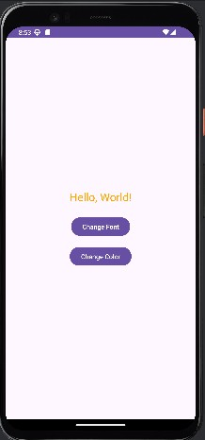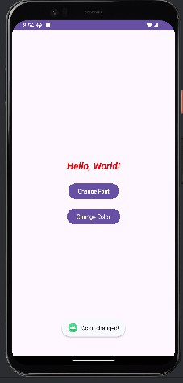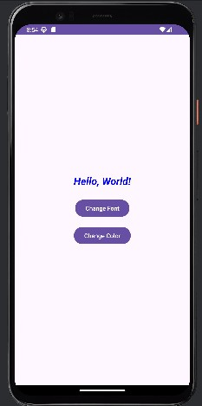

how()

**}**

}

}

***Output***

# Result:

**TheApplicationwasdevelopedusingKotlininAndroidStudio.**

8

**DepartmentofComputerScienceandDesign**| **RajalakshmiEngineeringCollege**

.